July 20, 2018

GW Data Analytics

Laura, Marthenya

Kathy, Annabelle

Washington DC | Parking Ticket Analysis (2017)

Motivations and summary:

There were 1,404,052 parking tickets issued in Washington, DC, in 2017. According to the Washington Post 2016 article entitled “DC is really good at writing tickets, Sometimes sneaky too,” the article state “D.C. writes more tickets per capita than most cities its size… No place in the country writes as many tickets.” Ticketing affects revenue, congestion and safety in the city as well as the bank accounts of D.C. drivers. This study aims to better understand the ticketing system by:

* Exploration of which parking violations are issued in DC
* Exploration of DC’s relationship to surrounding areas
* Basic behavioral study of when and where violations occur in the city

In order to explore these broad areas, the following questions were answered:

* How does time of the year affect the amount of violation tickets issued, and is this affected by the weather and temperature for each month?
* How does the day of the week affect the amount of violations, and whether it differs among seasons?
* What are the ten most frequently issued tickets and what is the projected revenue?
* Is there a discrepancy of violations types for: DC Residents, Virginia/Maryland Resident, Other states?
* What are the most frequently ticketed areas in DC?
* What are the lowest ticketed parking violations in the District of Columbia in 2017?
* What is the overall sentiment of the violation descriptions?
* What were the oddest ticketed parking violations in the District of Columbia in 2017?

QUESTION 1 How does time of the year affect the amount of violation tickets issued, and is this affected by the weather and temperature for each month?

One thing that must be noted before anything else is that what we are working with is the ticket issue date, rather than when the violation occurred. While the ticket issue date is the only concrete way we have to measure whether if a violation has occurred, it is not necessarily equal to when exactly the violation occurred. Thus, our analysis may be more on police officer behavior rather than driver behavior.

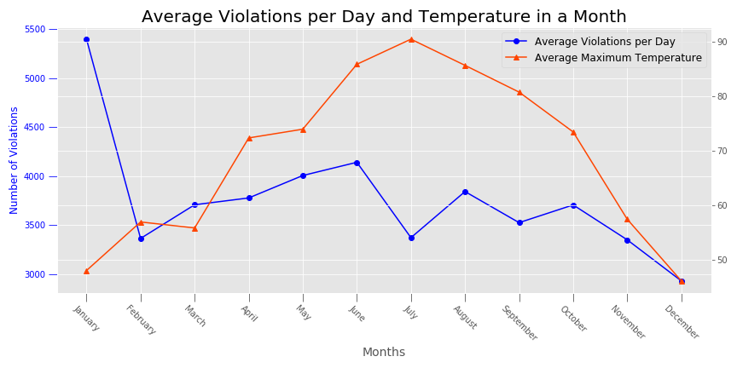

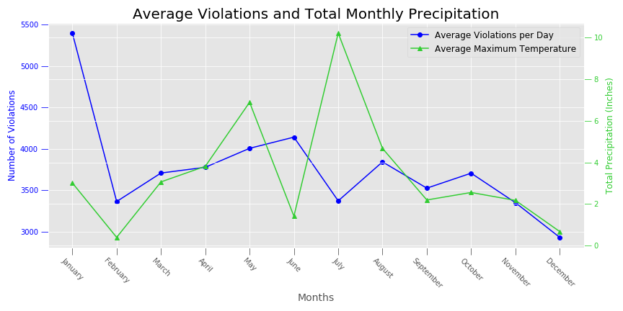When plotting maximum average temperature and average violations per day for each of the months in 2017, it appears that there isn’t a direct correlation between temperature and parking violations. What is evident though is that there is a huge spike in parking tickets issued in January. The numbers of violations fluctuate during the middle months and decrease in December. When plotted, the pattern of the average violations is almost identical to the total violations. A possible reasoning for the decrease in December is simply due to the holidays. There might be less drivers or officers in DC during the holiday season.

In the future, we can examine January in more detail, as there might be specific days in January in which there are more violations.

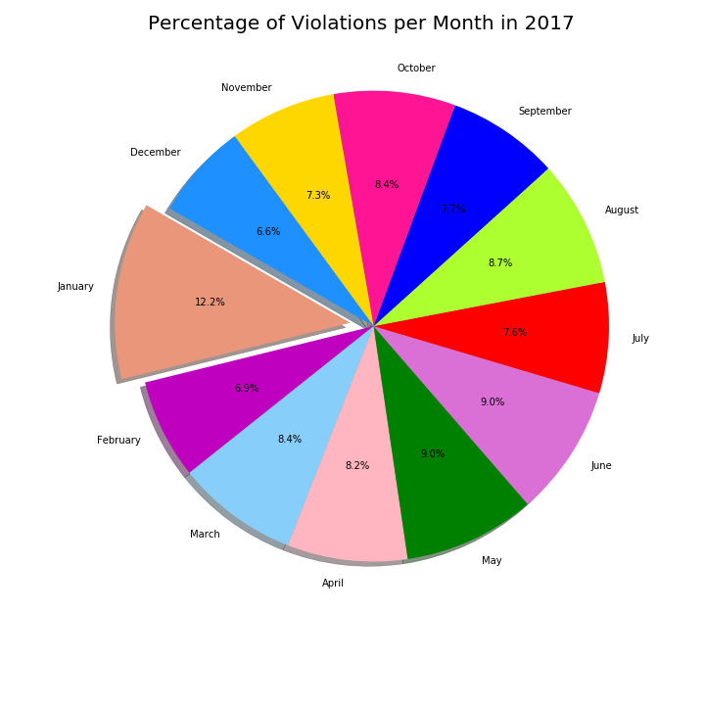When plotting the total precipitation per month to the average violations per day, there does not appear to be any obvious correlations. It is interesting to note, that there is a bit of a dip in violations in July, the month with the most precipitation, after the violations were steadily increasing from February to June. This may be a direct result of the precipitation (that there are less drivers or officers are less inclined to walk in the rain to hand out tickets), though without more data, it is difficult to make any solid conclusions.

January has the largest percentage of violations out of all of the months, taking up over 12 percent of the entire year. The other two winter months, February and December have the least number of violations (6.9% and 6.6% respectively) out of the entire year. The shorter length of February may be the main reason why there is less compared to the other months.

QUESTION 2) How does the day of the week affect the amount of violations, and whether it differs among seasons?

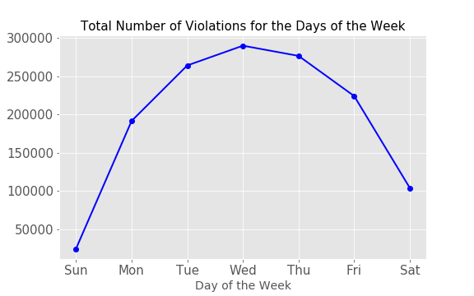

Frequency of violations throughout the week follow a curvature pattern, in which increases from Sunday and peaks on Wednesday, then dipping downwards towards Saturday. The lower number of parking violations during the weekend may simply be due to that there are just simply less restrictions on parking during the weekends, especially on Sunday.

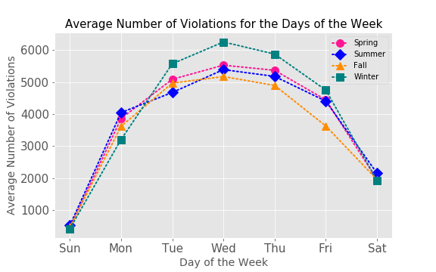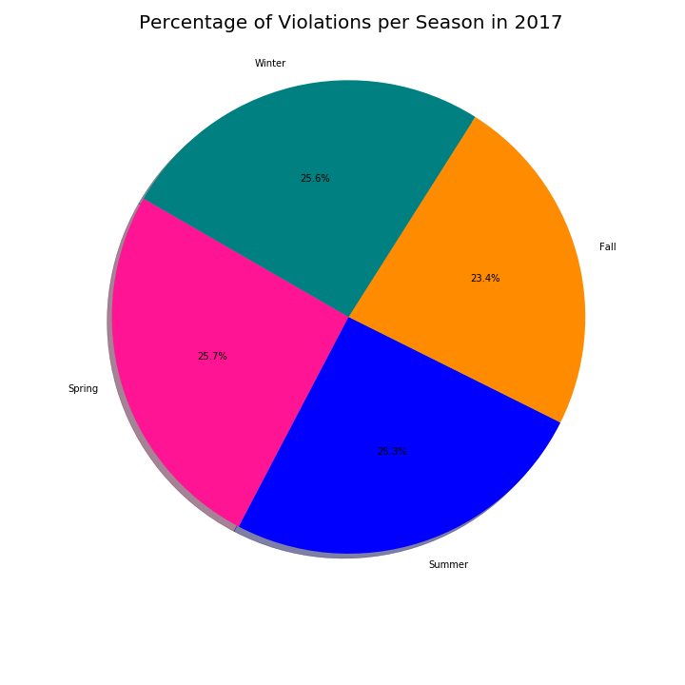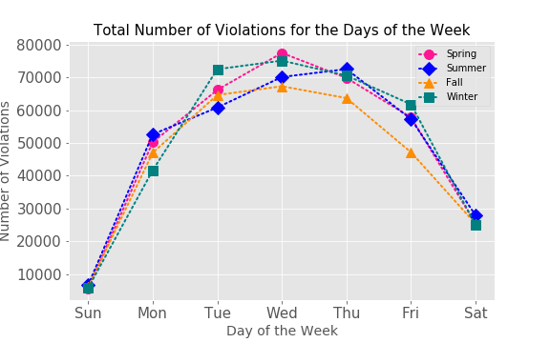Interestingly enough, the pattern of the total number of violations and the average number of violations by seasons across the days of the week are slightly different. There are no apparent differences among the seasons when we plot the total number of violations, but there seems to be more in winter (though only for the middle of the week) when plotting the average number of violations. This may or may not be related to the fact that there are so many violations in January compared to the other months. Percentage wise, the number of parking violations in winter is about even compared to the other months.

Something to note is that we only used one year’s worth of data and as a result, we only have one set of data for the seasons and months. As a result, month and seasonal data may not necessarily be the most reliable. We can perhaps also develop a stronger analysis for the relationship between weather and parking violations as we would also then have more weather data to work with.

Only a few of the CSVs we have worked with includes timestamps and as a result, we did not look at how violations change across the day. In the future we can pull the few CSVs that do have proper timestamps and examine whether there is a trend between time of day and number of parking violations.

QUESTION 3) What are the ten most frequently issued tickets and what is the projected revenue?

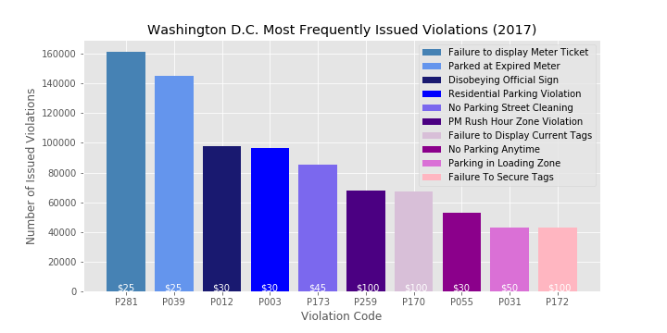

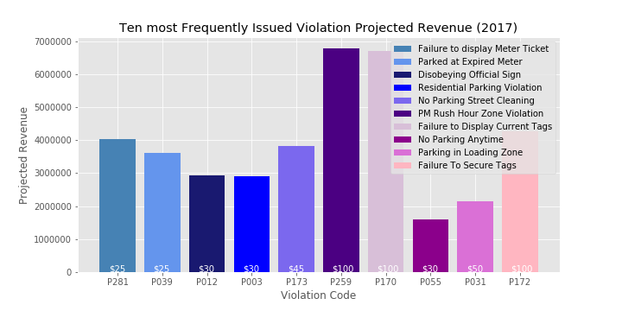

There were 1,404,052 parking tickets issued in Washington, DC, in 2017 providing a constant revenue source for the city. There were 215 violation categories, and the 10 most frequently cited violations account for 61% of tickets issued for the year. The two top violations for 2017 were “Failure to Display a Multispace Meter Receipt” and “Parking at Expired Meter.” These two violations accounted for 22% of all tickets issued.

The ten most frequent violations bring in a projected revenue of $38,812,030.

Though not the most frequently cited, ‘PM Rush Hour Zone Violation’, ‘Failure to Display Current Tags,’ and ‘Failure to secure tags,’ were the highest grossing. This is due to the fact that these carry a $100 fee whereas the other fees range from $25 - $50. The ticket revenue for the city relies both on the frequency of tickets issued as well as the fines associated with them.

Problems:

1)Revenue data was not available leading to best estimation.

2)Datasets that were not able to merge and some data had to be put in manually.

3)Drawing conclusions from human behavior.

QUESTION 4) Is there a behavioral difference of drivers in DC based on the state the car is registered?

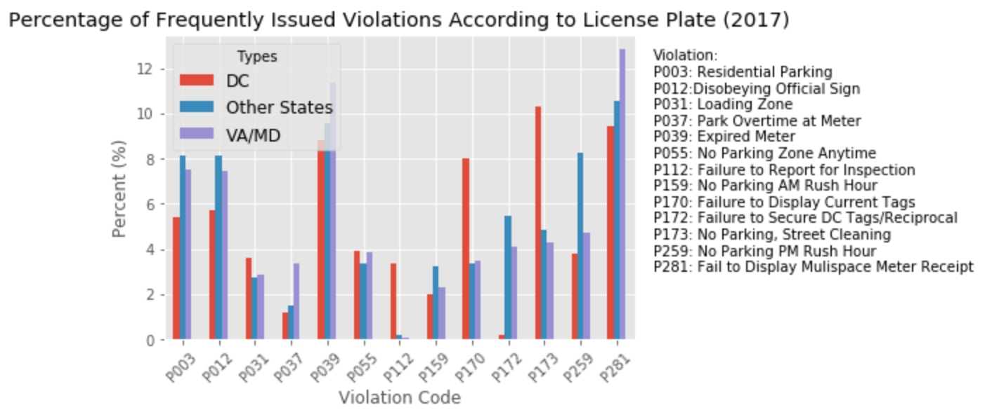

In order to better understand the behavioral difference of drivers in DC a study was created to understand if there was a violation percentage difference between vehicles registered in DC, vehicles registered in Virginia and Maryland, and vehicles registered in other states.

These are our findings:

Uneven scores

* DC received a greater percentage of P173 violations, No parking street cleaning, an average 5.77 percentage points higher than the combined average for the other groups
* Other States received a greater percentage of P259 violations, No Parking PM Rush Hour, an average of 3.98 percentage points higher than the combined average for the other groups
* VA/MD received a greater percentage of P281 violations, Fail to Display Multispace Meter Receipt, an average of 2.86 percentage points higher than the combined average for the other groups

The most evenly distributed violations

* P055, No parking zone anytime, with an average percentage difference of .42%
* P031, Loading zone, with an average percentage difference of .76%

Possible reasons for the uneven scores are that streetsweeper tickets will affect residents, People from other states are not aware of DC’s unique approach to PM rush hour, including lane reversals, and commuters from Virginia and Maryland receive failure to display tickets due to the high frequency they commute into the city.

Limitations:

Revenue specifically for 2017 is not calculated in our data. Projected revenue is difficult to predict due to a wide range of factors including late fines and unpaid tickets.

This study deals with human behavior both on the ticketed side and the person issuing the ticket. Due to this we cannot extrapolate exact reasons but can use analysis and common sense to hypothesize.

**Question 5) What are the most frequently ticketed areas in DC?**

-We unfortunately do not have a concrete list, per say, of the definitive most densely ticketed areas in DC. This is due to the fact that we did not have neighborhood, city, or ward information in our initial dataset – only lat and lon coordinates to plot on a map, and an ADDRESS_ID that means nothing to the average person. We can however discern based on multiple runs of the random sample dataset, and plotting these points onto a map, that the largest makeup of tickets being cited in DC come from the NW quadrant, typically surrounding the Chinatown, Dupont Circle, and Foggy Bottom areas.

I would have really liked to have been able to create some other visualizations outlining neighborhoods and/or wards – but that was not something we were able to do. We found a great dataset from the same resource as our main dataset (opendata.gov) – which had 147k rows including the ADDRESS_ID which is also present in our dataset, along with the corresponding neighborhood, zip code, city, quadrant, and many other pieces of information that would have enabled us to really dig deeper into the ticketing dataset we are looking to unpack. We merged these two dataframes, and unfortunately only 7% of our dataset had a corresponding ADDRESS_ID within the other file, rendering it useless for a complete analysis of any sort.

It was quite frustrating to continue to run the heatmap (using Folium) and have the first component finish without error (usually complete around the 2 hour mark before moving on to the actual plotting portion!) only to have the second step take another hour or two, and have the output be a large white box – the size in which a map would be plotted, but with nothing present. Not receiving an error message was a recurring source of frustration, as I had to learn on my own that if the dataset were downsized the map would plot. This is why we ended up going with a random dataset – for some reason, Jupyter won’t plot even 2000 records through Folium for my dataset.

Our output heatmap:

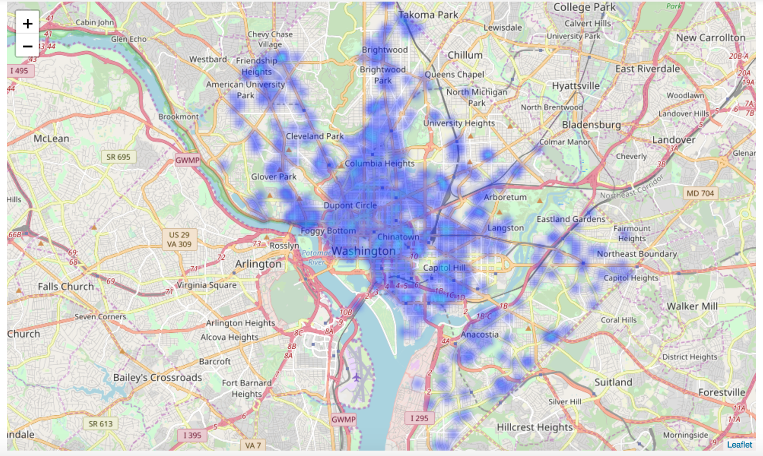

Our heatmap with clustered ticket plots:

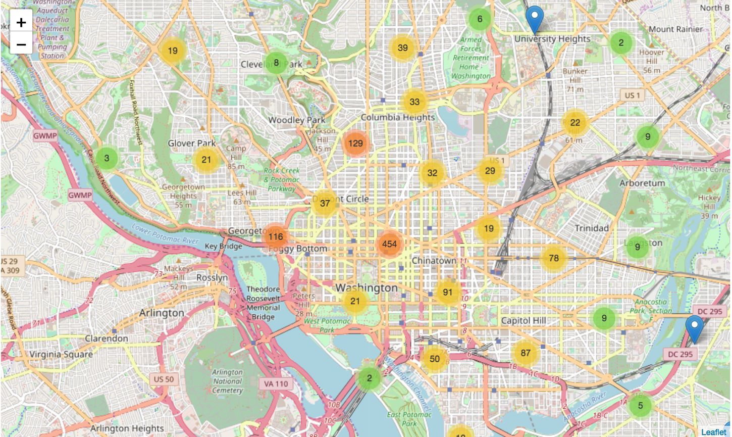

A more zoomed in version of our clustered heatmap:

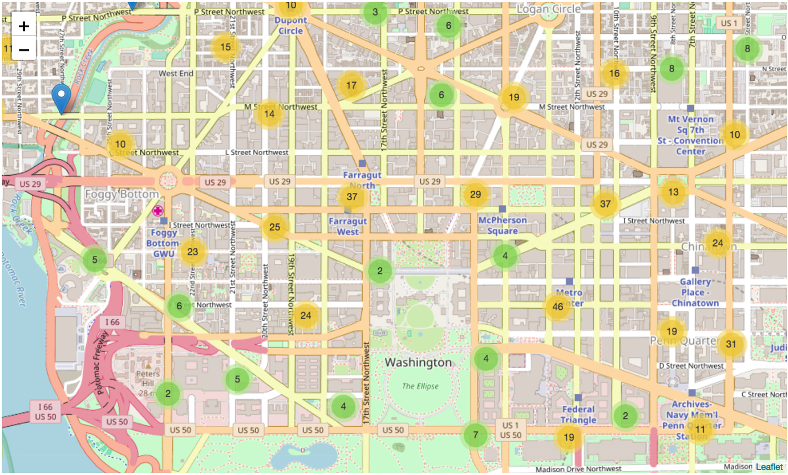

And finally, the farthest in one can zoom into this heatmap. This allows you to take a granular look at the street, what business/resturants/bars or other things that might cause higher traffic or high demand for parking might near by, etc.

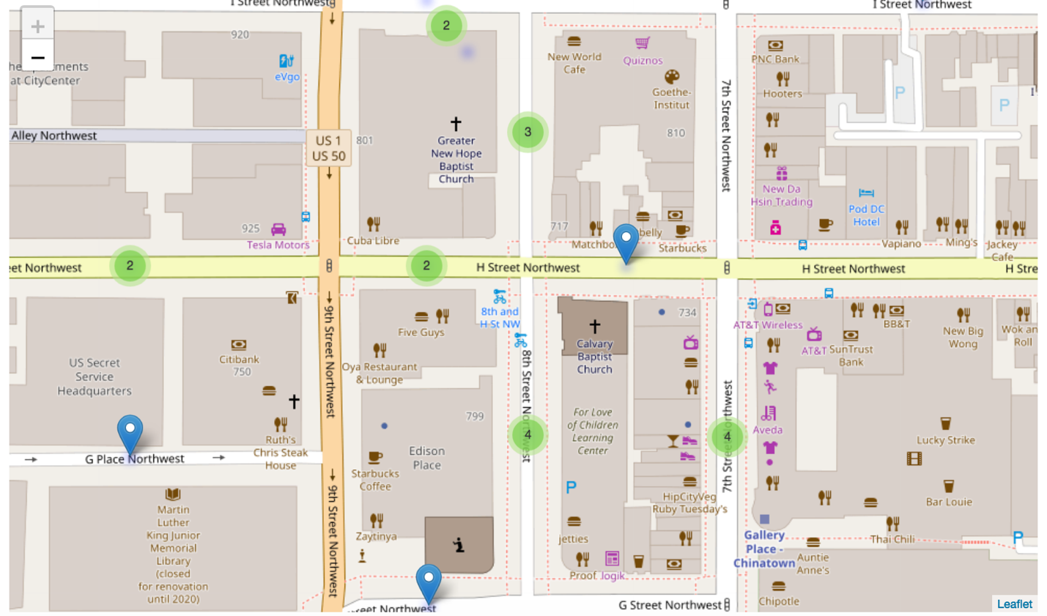

Questions would have liked to look in to or answer had we had more time or a more thorough location-based dataset:

1. What were the most prevalent neighborhoods for ticketing in 2017?
2. Are you more likely to be ticketed in a residential or a non-residential area? (or, are there more violation types for residential or non-residential area?)

2. What quadrants issued the most parking validations in 2017?

3. Dig deeper into how a location’s ticketing volume might change by season.

4. How DC’s ticketing rate stacks up against the rest of the country

Question 6: What are the lowest ticketed parking violations in the District of Columbia in 2017?

Question 7: What is the overall sentiment of the violation descriptions?

To answer these question, we created one dataframe showing the count of each violation description. Then, we sorted the data in descending order and took the first several rows of the dataframe. Since the data was sorted in descending order, this would give the lowest number of ticketed items. A second dataframe was created to add column headers and was used to plot the data.

Upon reviewing the data, we could see that there were hundreds of reasons a person could get a ticket. Realizing that there were only a few types that the average person would get, like expired meter, we wanted to uncover the rare tickets. We’ve found that the lowest ticketed violations are among the most unusual reasons a person would get a ticket. There were 33 violation types that were issued in 2017 only once.

|  |  |
| --- | --- |
| **Violation Description** | **Violation Code Count** |
| MOVING A LOAD OVER EIGHT FEET WIDE | 1 |
| DRIVE TRUCK ON RESTRICTED ROUTE | 1 |
| PROVIDE FALSE INFO TO OBTAIN TEMP PARKING PLACARD | 1 |
| PROVIDE FALSE INFO TO OBTAIN VISITOR PARKING PERM | 1 |
| TAXICAB NOT USING OFF DUTY SIGN | 1 |
| TAXICAB NO MANIFEST | 1 |
| EXCESSIVE SMOKE. | 1 |
| FAIL TO PROPERLY DISPLAY INSPECTION STICKER SIGN | 1 |
| LOAD EXTENDS OVER FENDER | 1 |
| TAXICAB FAIL TO UPDATE CHANGE OF ADDRESS | 1 |
| TAXICAB FAIL TO SHOW ID | 1 |
| PROVIDE FALSE INFORMATION TO OBTAIN RPP PERMIT | 1 |
| NO STOP LIGHTS | 1 |
| RESERVED SPACE NO PARKING | 1 |
| NO OR DISCONNECTED MUFFLER | 1 |
| TAXICAB CRUISING LIGHTS | 1 |
| DISPLAY METER RECEIPT FROM MTR OUTSIDE AREA BE | 1 |
| RPP BALLPARK EVENTS 2ND OFFENSE CALENDAR YEAR | 1 |
| METER ADD'L PAYMENT TO EXTEND TIME BEYOND LIMI... | 1 |
| DEFECTIVE SPEEDOMETER. | 1 |
| PARKING MISC | 1 |
| INCORRECT BUMPER ON A VENDING VEHICLE | 1 |
| TORN FENDERS | 1 |
| PARK IN A GUTTER | 1 |
| NO RED FLAG ON THE END OF A LOAD | 1 |
| NO REAR VIEW MIRROR | 1 |
| PARK IN A CURB LOADING ZONE | 1 |
| VEHICLE ON PRIVATE/PUBLIC PROP W/O CONSENT 3D OFF | 1 |
| NO SNOW TIRES OR CHAINS | 1 |
| UNNECESSARY NOISE. | 1 |
| MOTOR CARRIER HAZMAT VIOLATION OUT OF SERVICE | 1 |
| NO REAR LIGHTS. | 1 |
| GLASS LEFT IN THE STREET | 1 |

Residents and non-residents could even get ticketed for miscellaneous reasons. This data leads to conclude that the purpose of issuing “parking” tickets is not only for the purpose of managing specific parking issues in the District. It is a form of population control.

Since the lowest ticketed violation data consists of violations that were ticketed the exact same number of times, there was no benefit to creating a plot for it. Therefore, we decided to perform sentiment analysis and plot that data.

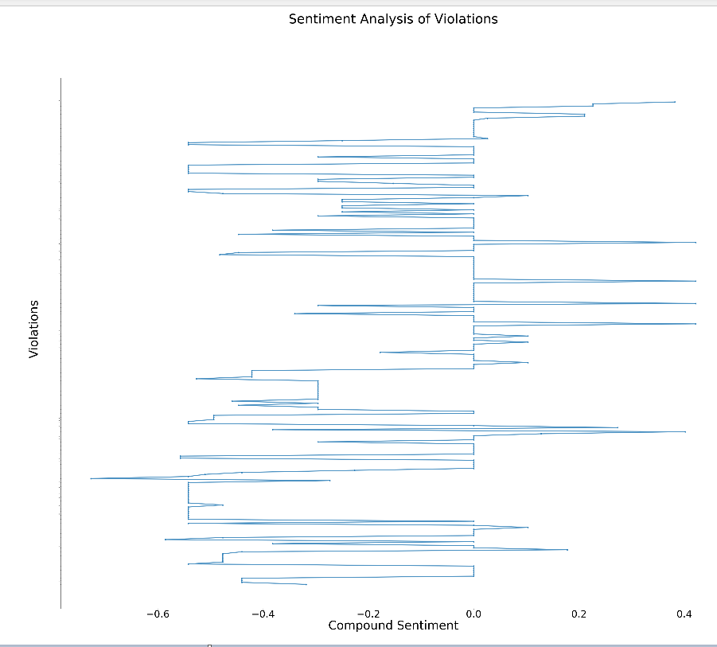

Looking at the chart, we see that the overall sentiment is negative. Seems fitting for the topic.

Question 8: What were the oddest ticketed parking violations in the District of Columbia in 2017?

To further look into the reasons a person could get a parking ticket in the district, we wanted to shed light on the top ten most noteworthily odd or humorous reasons to give someone a parking ticket. This data was manually selected and placed in lists for plotting.

We started by looking at "PARK WITH LEFT WHEEL TO CURB" and "FAIL TO TURN WHEEL TO CURB". There were 2,582 tickets issued for having the left wheel turned to the curb and only 28 tickets issued for failing to turn a wheel to the curb. Are we or are we not to turn the wheel? It seems the District wants to hedge its bets or, at the very least, are indecisive. Since only 28 people were ticketed for it in 2017, there are better odds with not turning any wheels when parked.

Next, we looked at "COMMERCIAL VEHICLE - NOT OUT OF SERVICE" and "COMMERCIAL VEHICLE - OUT OF SERVICE". There were 532 tickets issued for commercial vehicles that were not in service and 311 for those in service. This is another situation where it appears the District is indecisive about what to allow and therefore creating vague contradictory violations. It is doubtful that the vehicles were ticketed because there were in or out of service alone. If they were, then it’s more beneficial for commercial vehicles to park while out of service.

Next, we discovered that non-residents of DC could get a ticket for "FAILURE TO SECURE DC TAGS" when parked overnight. There were over forty-two thousand tickets issued in 2017. This data would be very useful for those who visit loved ones and is not well publicized. Here is more information about the requirements: <https://dmv.dc.gov/service/registration-out-state-automobile-rosa-0>

There was one ticket issued for "UNNECESSARY NOISE". While one could assume this is for those who add upgrades to their cars to make them sound sportier, one could only guess how the standards for “unnecessary” are defined.

Briefly stated, it may seem like common sense to not want to do these things; however, this data could be useful for those who don’t know it is illegal to park in a gutter, fail to lock the car and remove key from ignition, or park in an unlighted parking area. One may also want to keep yard tape in their car because 255 tickets were issued in 2017 for parking to reduce the roadway to less than 10 feet.

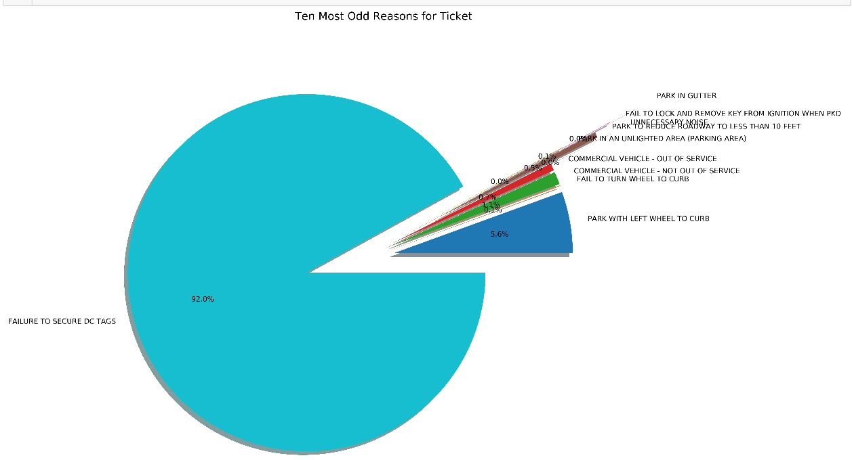

Conclusion:

Washington D.C. parking violations is a huge system, in 2017 issuing 1,404,052. The system creates positive effects such as increased safety and better traffic flow, and a revenue source for the city. Also, it creates negative effects such as placing a financial burden on commuters. In fact when sentiment analyzer read the ticket violations even it could discern the negative connotations of the tickets.

The large dataset created an opportunity to see overall trends in a variety of subjects. that were difficult to overcome in others. January sees the largest spike in ticketing and December the lowest. Weekends see a definite drop in violations issued. Seasons have very little effect on the number of tickets issue. With a large sample set we can clearly discern the most frequently issued tickets, projected revenue, the least issued tickets and some humorous reasons for ticketing. Finally, we are able to calculate behavioral difference of drivers in DC based on the state the car is registered.

The large dataset also created issues in answering some questions. Mainly, mapping over a million points on a 68.34 squared miles creates more havoc than pattern. A work around to create sample data was established and we were able to draw some conclusions the largest makeup of tickets being cited in DC come from the NW quadrant, typically surrounding the Chinatown, Dupont Circle, and Foggy Bottom areas.

Additional analysis would further help our understanding of D.C.’s ticketing system. Additional information of locations of tickets broken into wards or specific neighborhoods would aid in mapping. Conducting the same study but using multiple years would further prove our outcomes. Also, obtaining specific revenue information for multiple years would lead to more concrete conclusions.